**WEEK-4**

**4.1**

**Key Topics: ServiceNow ScriptingTutorials | Scripting in ServiceNow |ServiceNow Scripting Full Course**

**Sub-topics: Scripting on the ServiceNow platform in this course.**

### **What is Server-Side Scripting?**

* Server-side scripting is code that runs on the ServiceNow server, not in your web browser. It handles things like managing data, automating tasks, and applying business rules. Think of it as the behind-the-scenes work that makes sure everything runs smoothly.

### **What is Client-Side Scripting?**

* Client-side scripting is code that runs in your web browser while you’re using ServiceNow. It makes the user interface (UI) interactive and responsive. This means that actions you take on a page (like clicking a button or changing a field) can immediately trigger changes or actions without needing to refresh the entire page.

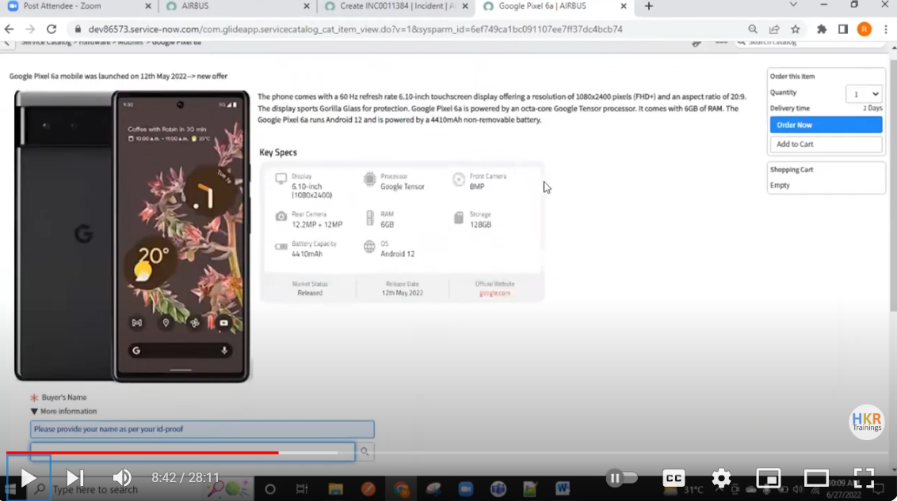

**4.2**

**Key Topics: What is ServiceNow |ServiceNow Tutorial forBeginners |ServiceNow FullCourse**

**Sub-topics:Understanding of how ServiceNowfunctions, how to properly configure and personalize the platform, IncidentModule, ProblemModule, ChangeModule, List, Forms01**

**What is Servicenow?**

* ServiceNow is a cloud based platform, which was mainly developed for workflow and process automation as per the ITIL principles.
* However, it is highly customisable and also can be used for other purposes.

**How to get free snow instances**

**Step 1:** SignUp from https://developer.servicenow.com/dev.do#!/home

**Step 2**: Fill the Registration form

**Step 3:** Verify your account

**Step 4:** Now Login to your ServiceNow Developer Platform.

**Step 5:** Request/create an instance.

**Step 6**: Choose the ServiceNow Developer Instance Version

**Step 7:** Instance Credentials Info

**Step 8**: Login into your ServiceNow Developer instance.

**Instance Activity**

⦁if the instance is inactive for 10 days, then the instance is released

⦁If your instance is inactive for more than 24 hours, then your instance may go into hibernation.

**How to become a SNOW Developer?**

**⦁** Get a Bachelor's Degree CSE or IT

⦁ Learn JavaScript & ITIL basics

⦁ Get ServiceNow Course

**Overview of ServiceNow UI.**

⦁ServiceNow is a cloud-based platform with customizable user interfaces. The user interface has evolved from UI 15 to UI 16 in recent releases.

⦁ServiceNow releases a new version every six months, named after cities, with quarterly performance updates.

⦁The interface components include a banner frame, content frame, and navigation frame, each serving specific purposes.

**BANNER FRAME**

**Banner Frame: User Menu**

User Menu contains:

1. Profile: Profile settings allow users to change personal information such as name, phone, date format, email, and time zone.

2. Impersonate User: Impersonation feature is available for administrators or impersonators to view the system as another user, useful for troubleshooting.

3. Elevate Roles: Role elevation is a security mechanism for high-impact actions, requiring administrators to elevate their roles temporarily.

4. Logout: Logout option in the user menu to exit the ServiceNow instance.

**Banner Frame: Tools**

There are 3 main tools:

1. Global Search: It is used for searching records.

2. Connect Chat: It is used for real-time messaging.

3. Contextual Help: It is used for assistance based on the current context.

**Banner Frame: System Settings**

1. General settings include options to compress the UI, enable/disable keyboard shortcuts, and set the home page link.

2. Theme settings allow users to change the color scheme of the interface, useful for distinguishing between different instances.

3. Menu settings control the appearance of data lists and long text wrapping in columns.

4. Notification settings manage the types of notifications received and their delivery methods, while developer settings include options for application scopes and update sets.

**Content Frame:**

⦁The Content Frame is the main part of the ServiceNow screen where you see and interact with information. Here, you can work with forms, lists, dashboards, reports, and other data related to the app or module you're using. It’s where most of your work gets done.

**Application Navigator**:

⦁The Application Navigator in ServiceNow is a component located on the left side of the interface that provides a way for users to quickly access different applications, modules, and functionalities within the platform.

⦁Applications are the Collection of files and data, they serve as the building blocks for delivering services such as IT, HR resource management, Service Desk etc. Modules are the individual functionalities or operations available under each Application.

⦁We can Pin the Applications and modules to favorites for quick access. We can use the Favorites to mark the application that we frequently use and have quick access to it. We also have a history option to look at our recent actions. Default is last 30 items we have accessed

**ServiceNow Components:**

⦁The Components are the basic elements of your page.

⦁Components range from the basic elements like labels, and buttons to more complex experience components like lists and forms.

⦁These components can be added to your page to create or personalize your workspace or portal.

**Modules:**

⦁Modules are the elements that make up the ServiceNow application navigator

**Some of the modules in ServiceNow are:**

Incident Management

Problem Management

Change and Release Management

Request Management

Asset and Cost Management

Walk-Up Experience

Agent Workspace

Now Mobile, etc.

**Incident Module**

⦁The Incident Management module in ServiceNow is designed to handle and manage incidents efficiently within an organization. Here's a high-level overview of how it works and its key components

⦁An incident is a situation where normal service operations are interrupted, disrupted or degraded.

⦁In ServiceNow, an open incident indicates that the customer is strongly affected or it represents a business risk.

⦁The process of managing the incident lifecycle is called as an Incident management

**Problem Module:**

⦁A problem is a cause of one or more incidents.

⦁The process of managing the lifecycle of all the problems that arises or could arise in an IT service is called as Problem management

**Change module:**

⦁The Change Management module in ServiceNow helps organizations manage changes to their IT systems and infrastructure in a structured and controlled manner. The module aims to ensure that changes are made with minimal risk and disruption to the organization’s services

⦁Changes are managed through the change module, which includes emergency, normal, and standard changes.

⦁Emergency changes require immediate attention, normal changes require approvals, and standard changes are pre-authorized.

⦁Change requests include details like risk, priority, and schedule, and follow a lifecycle from planning to closure.

⦁The change module ensures controlled and authorized changes in the ServiceNow environment.

**List:**

⦁Lists show records from a table in a grid or table format, making it easy to view, filter, and sort multiple records at once. Each database table in ServiceNow has its own list view

⦁List view displays a set of records in a table format, while form view provides detailed information for individual records.

**You can access lists in three ways:**

⦁Application Navigator: Navigate to the list through the application navigator by selecting the appropriate module.

⦁Dot List Command: Use the dot command (e.g., incident.list) in the application navigator to quickly open the list.

⦁Sys_db_object Command: Use the sys_db_object.list command to see a list of tables, then select the one you want.

Using Table_name.list opens the list view of a specific table, and Table_name.LIST will open it in a new tab.

The List Header in ServiceNow provides several tools to help you manage and interact with lists:

⦁List Controls: These are options for actions you can take on the list or its items.

⦁List Control Menu: Includes options like changing views, applying filters, grouping items, refreshing the list, and creating favorites.

⦁Column Option Menu: Lets you configure the column settings, import data, create reports, and sort the list.

⦁List Field Menu: Used to copy the sys_id of a record, which is a unique identifier in ServiceNow.

⦁Filter Lists: Allows you to search and apply filters to narrow down the list of records.

⦁Table Search Bar: Enables you to search for specific records within the list.

⦁Personalize Icon: Lets you customize the list view to fit your preferences.

**Filter**

A filter in ServiceNow is used to narrow down the data in a table list by applying specific conditions. Here are the three main parts of a filter condition:

⦁Field: This is the specific data field you want to filter by. It includes options from the table you’re working with and can also include fields from related tables through dot-walking.

⦁Operator: This defines how the filter should compare the field’s value. The options vary depending on the type of field you are filtering (e.g., “is,” “contains,” “is greater than”).

⦁Value: This is the criteria you are looking for in the field. It can be a text entry or a choice from a list, depending on what type of data the field holds.

**Steps to Create a Filter in a List**

⦁Open the List:

⦁Navigate to the list where you want to apply the filter (e.g., Incidents, Change Requests).

⦁Access Filter Options:

⦁Look for the Filter icon or menu, usually located in the list header. It might look like a funnel or be labeled “Filter.”

⦁Create a New Filter:

⦁Click on the Filter icon or menu, then select Create Filter or Add Filter Condition.

**Breadcrumbs**

The Breadcrumbs Filter conditions applied to the list are summarized in the breadcrumbs, shown in blue letters across the top of the list. Not only do the breadcrumbs provide an “at-a-glance” view of the filter’s conditions, but they allow you to modify conditions as necessary. For example, you can select the greater than sign before a condition to remove that condition or select a breadcrumb to remove all of the conditions that follow. Group By - It is used to group the list records based on a field.

Refresh List - Used to refresh list to reflect the recent changes.

Group By: This feature allows you to organize the list records based on a specific field, grouping similar records together for easier viewing.

Refresh List: Use this option to update the list and reflect any recent changes or updates.

List Personalization:List Personalization lets you customize how a list appears for your own use without changing the default layout for everyone. Here’s what you need to know:

⦁Personalize List: This feature allows you to adjust the layout and display of a list just for yourself. These changes are specific to your user account and don’t affect how others see the list.

⦁Temporary Customization: Personalization are meant for temporary adjustments. If the system or admin makes global changes to the list view, you won’t see those changes in your personalized list until you reset it.

⦁Reset to Column Defaults: If the system administrator updates the default list view, you won’t see these updates until you choose to reset your personalized list to the default settings.

**List Layout Configuration**

List Layout Configuration in ServiceNow involves adjusting the columns or fields displayed in a list view. This is typically done by administrators and affects how all users see the list. Here’s how to configure the list layout for a table:

⦁Navigate to the List:

⦁Go to the list you want to configure and make sure you’re viewing it in the correct mode or view.

⦁Access Column Options Menu:

⦁Click on the options menu for any column in the list (usually represented by a gear icon or similar).

⦁Configure the List Layout:

⦁Select Configure from the menu.

⦁Choose List Layout to open the configuration options.

**Forms**

Forms are user interfaces that allow you to view, create, and edit records in the database. Each record type is linked to a specific table, and there are thousands of forms available to manage the extensive data structure within ServiceNow. Forms help users interact with and manage data effectively by providing a structured way to input and display information.

**Header Bar:**

⦁The header bar is the section at the top of a form or list that provides key information and controls related to the record or list.

Read-Only Fields:

⦁These fields display information that users cannot edit. They are often used for data that should be viewed but not changed, like record IDs or system-generated timestamps.

Required Fields:

⦁These fields must be filled out before the form can be saved or submitted. They are marked with an asterisk (*) or other indicators to show that they are mandatory.

Sections:

⦁Organize fields into logical groups to improve form readability and usability.

Formatter:

⦁Displays additional information or instructions that aren't part of the standard fields.

Related Lists:

⦁Show records from related tables that provide context or additional information about the current record.

**Fields:**

⦁Fields in ServiceNow forms are the individual elements where users input, or view data related to a record. Each field corresponds to a specific type of information.

Field types

⦁Reference Field: Allows users to select records from another table.

⦁Document ID: Provides a way to select records from multiple tables using a unique identifier.

⦁Date/Time: For selecting dates and times, often with a calendar widget.

⦁String: For entering text, including letters, numbers, and special characters.

⦁Choice List: Provides a drop-down menu of predefined options for users to choose from.

⦁True/False: Represents binary choices using a checkbox, where checking the box indicates "True" or "Yes," and leaving it unchecked indicates "False" or "No."

⦁Saving Changes:Saving changes to your records is a manual process.

⦁Submit: This action saves the changes and closes the form. For new records, the button will say "Submit." For existing records, it will say "Update."

⦁Save: This option saves your changes but keeps the form open, allowing you to continue making modifications.

⦁Unsaved Changes Warning: If you try to navigate away from the form without saving, you will receive a warning about the unsaved changes. This alert will prompt you to either save or discard the change before leaving the form.

**Form Formatters**

Formatters are used to display information on a form that isn't stored as a standard field. They help enhance the user interface by showing additional context or data. Its types are

⦁Activity Formatter: Shows a list of activities or history related to the record. This includes journal entries like comments and work notes. Helps track changes and communications associated with the record.

⦁kProcess Flow Formatter:Displays the different stages of a process in a linear flow at the top of the record. Provides a visual representation of the record's progress through various stages.

⦁Parent Breadcrumbs Formatter: Shows breadcrumbs indicating the parent or related tasks of the current record. Helps users navigate through hierarchical relationships and see the context of the current task.

⦁Approval Summarizer Formatter: Provides a dynamic summary of the request being approved. Gives a concise overview of the approval request details and status.

⦁CI Relations Formatter: Displays the Configuration Item (CI) form and shows the relationships between the current CI and other related CIs.Helps visualize how different CIs are connected and their dependencies.

**Form Templates**

Form Templates in ServiceNow make it easier to create new records by using pre-set forms with some fields already filled in. This saves time and avoids repeating the same data entry.

**Form Design Tool:**

⦁A drag-and-drop tool that lets you easily move and arrange fields on a form.

⦁Makes it simple to design and change how forms look by letting you place fields and sections wherever you need them.

**Form Layout Device:**

⦁A tool for managing which fields appear on a form and how they are arranged.

⦁Makes it easy to add or remove fields from the form to fit your needs.